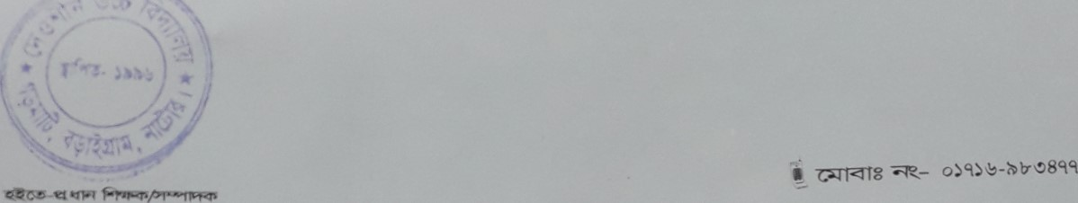



DEWSHIN HIGH SCHOOL



Email Address: www.dewshinhighschool bd@yahoo.com

Web address: www.dewshinhs.edu.bd







